COMMON OR CONDOM SENSE

What is a Condom?
It is named after a 17th century British Colonel who was supposed to have invented them. It is a protective sheath worn over the male penis (private part) during sexual intercourse. It is usually made of a very thin latex rubber. It was originally made to prevent pregnancy in a woman by keeping the male seminal fluid within the sheath so the woman could not be impregnated. It later became useful in helping to lessen sexually transmitted diseases (STDs) and now is also used to help lessen HIV infection during sexual intercourse.

TEST 22

Are There Different Kinds?

TEST 08
Yes, there are different brands, types, sizes, and differences in effectiveness in condoms. More recently they have even made condoms in different colours. Some (especially those given out in free distribution) are the plainer type. Others come with a special lubrication, special thickness, etc., to give easier penetration during sexual intercourse and for greater effectiveness.

How Safe Are Condoms?

TEST 08
There is much misinformation about condoms. Some people (particularly those in the business of making money out of them) say they are SAFE sex, meaning they are 100% effective. Others who have a belief system that promotes no-sex-outside-of-marriage (such as Christians) often claim they are not effective at all. Both of these opinions are incorrect.

TEST 01

Condoms and Pregnancy Prevention

Condoms were originally made to prevent pregnancy in a woman, by the man wearing the condom over his penis during sexual intercourse. This prevented the semen containing sperm that fertilise the female egg and make a baby, from injecting into the woman and causing impregnation. Studies have shown that using a condom to prevent pregnancy still has a failure rate of minimally 10% in knowledgeable adults, and in excess of 20% in younger people. Although the man can never fall pregnant, and a woman can only fall pregnant for one to three days in her monthly menstrual cycle, condoms do fail to prevent pregnancy even at that!

TEST 02

What About Condoms and HIV Prevention?

TEST 03

We must look at the effectiveness of condoms to prevent HIV infection by two factors:

- The condom (product) itself. Careful information has been gathered by the authors of this manual from most of the world’s condom manufacturers relative to their effectiveness in preventing HIV infection. Their effectiveness falls between an approximate 55% rate to a 98% rate depending on many factors. Some of the “product” factors that the user of a condom must consider are:

TEST 23
- That the condom has not been damaged before you use it
- That the size fits the male properly
- That the condom was stored prior to use in a cool, dry and dark place. Heat, light and humidity all damage rubber, so storage and shop conditions need to be checked before use
- Condoms must be used prior to their expiry date. Longevity of storage can render a condom less effective
The actual manufacturing effectiveness can also have a great bearing on the safety of the condom itself. Some brands carry a greater tracking of safety than do others. Unfortunately, most users cannot accurately determine some of the ‘product’ factors when they are given or purchase a condom. They must then hope that the product itself will give them maximum protection. Man-made materials such as latex rubber do sometimes have microscopic holes (called voids). Because the HIV virus is so much smaller than the male sperm, and so much smaller than some of the holes that can be in the material of the condom itself, the condom is not 100% effective.

Example of one of the better US-based condoms. This article was written by C.M. Roland for the Washington Times on April 22, 1992 with the accompanying picture (Test 04; Test 05) illustrating the possibility of the following:

TEST 04
- holes or voids in the condom
- the size of the virus compared to the male sperm
- possible holes in a condom, and the risk factor when it comes to HIV

While this illustration may not be the same in every condom, it gives a clear
example of the possibility of HIV infection when using a condom. Similar
risk is also present for other sexually transmitted diseases (STDs).
Condoms do lessen the risk of infection, but they are not foolproof.

- The user of the condom (the male). The condom’s effectiveness in preventing HIV infection also depends on the “user” of the condom and if he correctly uses it. The following are some factors that must be adhered to when using a condom to prevent both pregnancy and HIV infection, as well as other sexually transmitted diseases:
- Must open the packet without damaging it
- Must make sure the size is correct
- Must be certain that he uses a water-based lubrication (e.g. KY Jelly).
Vaseline, oil, etc., are all oil-based and if used with a condom will cause it to break
- Must put the condom correctly on the male penis before sexual intercourse
- Must leave some space at the end of the condom when putting it on and not break it taking it off
- Must be certain it stays intact during sexual intercourse
- Must be certain that sexual contact is finished before it is taken off
- Must be certain not to reuse a condom

The condom approach ONLY in stopping HIV and AIDS, without the balance of teaching moral behaviour and sexual responsibility, has failed to stop AIDS everywhere in the world. When HIV and AIDS first became a crisis worldwide, many countries began massive campaigns costing millions of dollars to mass distribute condoms. This approach neglected to teach moral behaviour, wrongly believing that condoms alone would solve the AIDS crisis. Much more money has been spent on proclaiming a ‘condom’ message to this generation with AIDS than on the ‘moral’ prescription God gives. God’s standard, which is no sex outside of marriage, prevents all STDs including AIDS. Thus, HIV and AIDS has spread becoming a worldwide catastrophe, especially in Africa. More condoms have been distributed to the present generation than ever before, yet HIV infection and AIDS continues to rise at an alarming rate, possibly wiping out a greater portion of today’s young African population. Educators must be responsible to teach the whole truth to this generation regarding the issues surrounding sexuality, AIDS, the condom, and life.

SEXU 09

The Example of Uganda

Uganda was one of the nations in the world with the highest rate in regards to the spread of HIV infection causing AIDS. More recently Uganda has been the single African country that is reporting containment of HIV spread. In Uganda, there are a number of reasons that can account for the decrease in the spread of HIV:

- Direct involvement of the President and government leaders. It is understood that the President of Uganda took the pandemic of HIV and AIDS so seriously that he himself got involved at the grass roots level in educating people about the behaviours that put a person at risk for AIDS.
- Direct Government involvement from the top down has infiltrated through the varying sectors of community leadership so that behaviour skills and moral skills are practically communicated in the nation.
- National leadership began to balance the message of condom effectiveness with moral responsibility in sexual behaviour in national education. Loudly and clearly the message of sexual responsibility, delayed sex for single people, and faithfulness in marriage is now receiving a high national profile. This is in contrast to many nations who are spending large amounts of government money on educational programs that put the condom as FIRST priority education for HIV prevention.

SEXU 68
- Sexual behaviour in terms of educational money spent and information communicated to the masses is given first priority in Uganda. Several other African governments are slowly adopting a more correct philosophy with regards to HIV and AIDS prevention, as follows:

SEXU 68
A -bstinence
B -e faithful
C -ondomise

Biblically, “A” and “B” will do away with the need for condoms as a means of HIV prevention. “A” and “B” are the only truly SAFE sexual practice. God knew that in the beginning by prescribing sexual purity for all people. “C” is an option if one is prepared to risk possible infection, however, it should be noted that “C” is not 100% safe sex from HIV infection and/or other sexually transmitted diseases (STDs). “C” might be best described by CHRIST in your life!

Four Choices One Has Regarding His/Her Sexual Behaviour

STAT 13
In teaching about the condom, instruction of personal empowerment needs to be given so that each individual is able to make wise choices for his/her life.

These choices are:

SEXU 03
- If I get a sexual feeling in my body and I want to have sex with a particular person, I will do it if I want. This is the first option and is high risk for HIV infection and sexually transmitted disease (STDs). Every person has this choice. Yes, he/she can take this option to have numerous sexual partners (even though it may be one at a time). In the day and age of AIDS, a person making this choice will probably contract HIV and die of AIDS prematurely. Most people who take this option for a lifestyle have many relationships that are short-lived, and most certainly are outside the perimeters of faithfulness in marriage. Many individuals selfishly choose to live in this manner, without regard to the severe consequences to themselves, their spouse, or their children. However, those who have chosen this option and contracted AIDS through risky sexual behaviour should not be shunned, discriminated against, or judged harshly. The Christian must always remember that “all of us have sinned and come short of the glory of God” and that Jesus Christ loves the sinner while He hates their sin.

SEXU 04

SEXU 10

SEXU 70

TEST 09
- If I get a sexual feeling in my body and I want to have sex with a particular person, I will do it, but I will use a condom. This is Option
# 2 where a person decides to have sex with more than one partner in a lifetime and uses a condom. It carries a medium risk for HIV infection and STDs. However, there is still risk involved, albeit, less than the first option. The following question must be asked by each person making this choice: How much risk am I prepared to take for sex, to contract HIV and AIDS? If people choose to have sex outside of marriage, then this is the question they must ask themselves. Is it a 2% risk, 5%, 25%? The problem with this #2 choice is that a person cannot accurately know what risk he or she is taking when using a condom. Using a condom is better protection against HIV and AIDS than using nothing at all, if you are going to take risk (Option #1) in sex outside of marriage. However, it is important to note that those who have sex outside of marriage using a condom, cannot know the following accurately:

TEST 07
- How that condom has been stored and how effective the ‘product’ is
- How many holes or voids might possibly be in the manufacturing of the materials in the condom. It differs from brand to brand and condom to condom

A man can learn proper ‘use’ of the condom, but there are a number of factors that are outside of the empowerment of condom users in trying to prevent HIV and AIDS, which is a ‘product’ factor. Is any sex worth contracting a fatal disease?

- I will have sex with a known partner and use a condom. This option is a low risk option and safer than Options # 1 and 2. Again however, there is possible risk for HIV and other STD infection because of the fact that either partner with this lifestyle is more likely to be ‘in’ and ‘out’ of sexual relationships more than once in a lifetime. If one chooses to sleep with a person outside of marriage, the chance of that relationship lasting a lifetime is not good. One also must remember that in going to bed and having sex with a person, one is not just sleeping with that individual. They are sleeping with every other person that partner has ever slept with in their lifetime. It is just as though all the sex partners of both persons are all crawling into the same bed together.
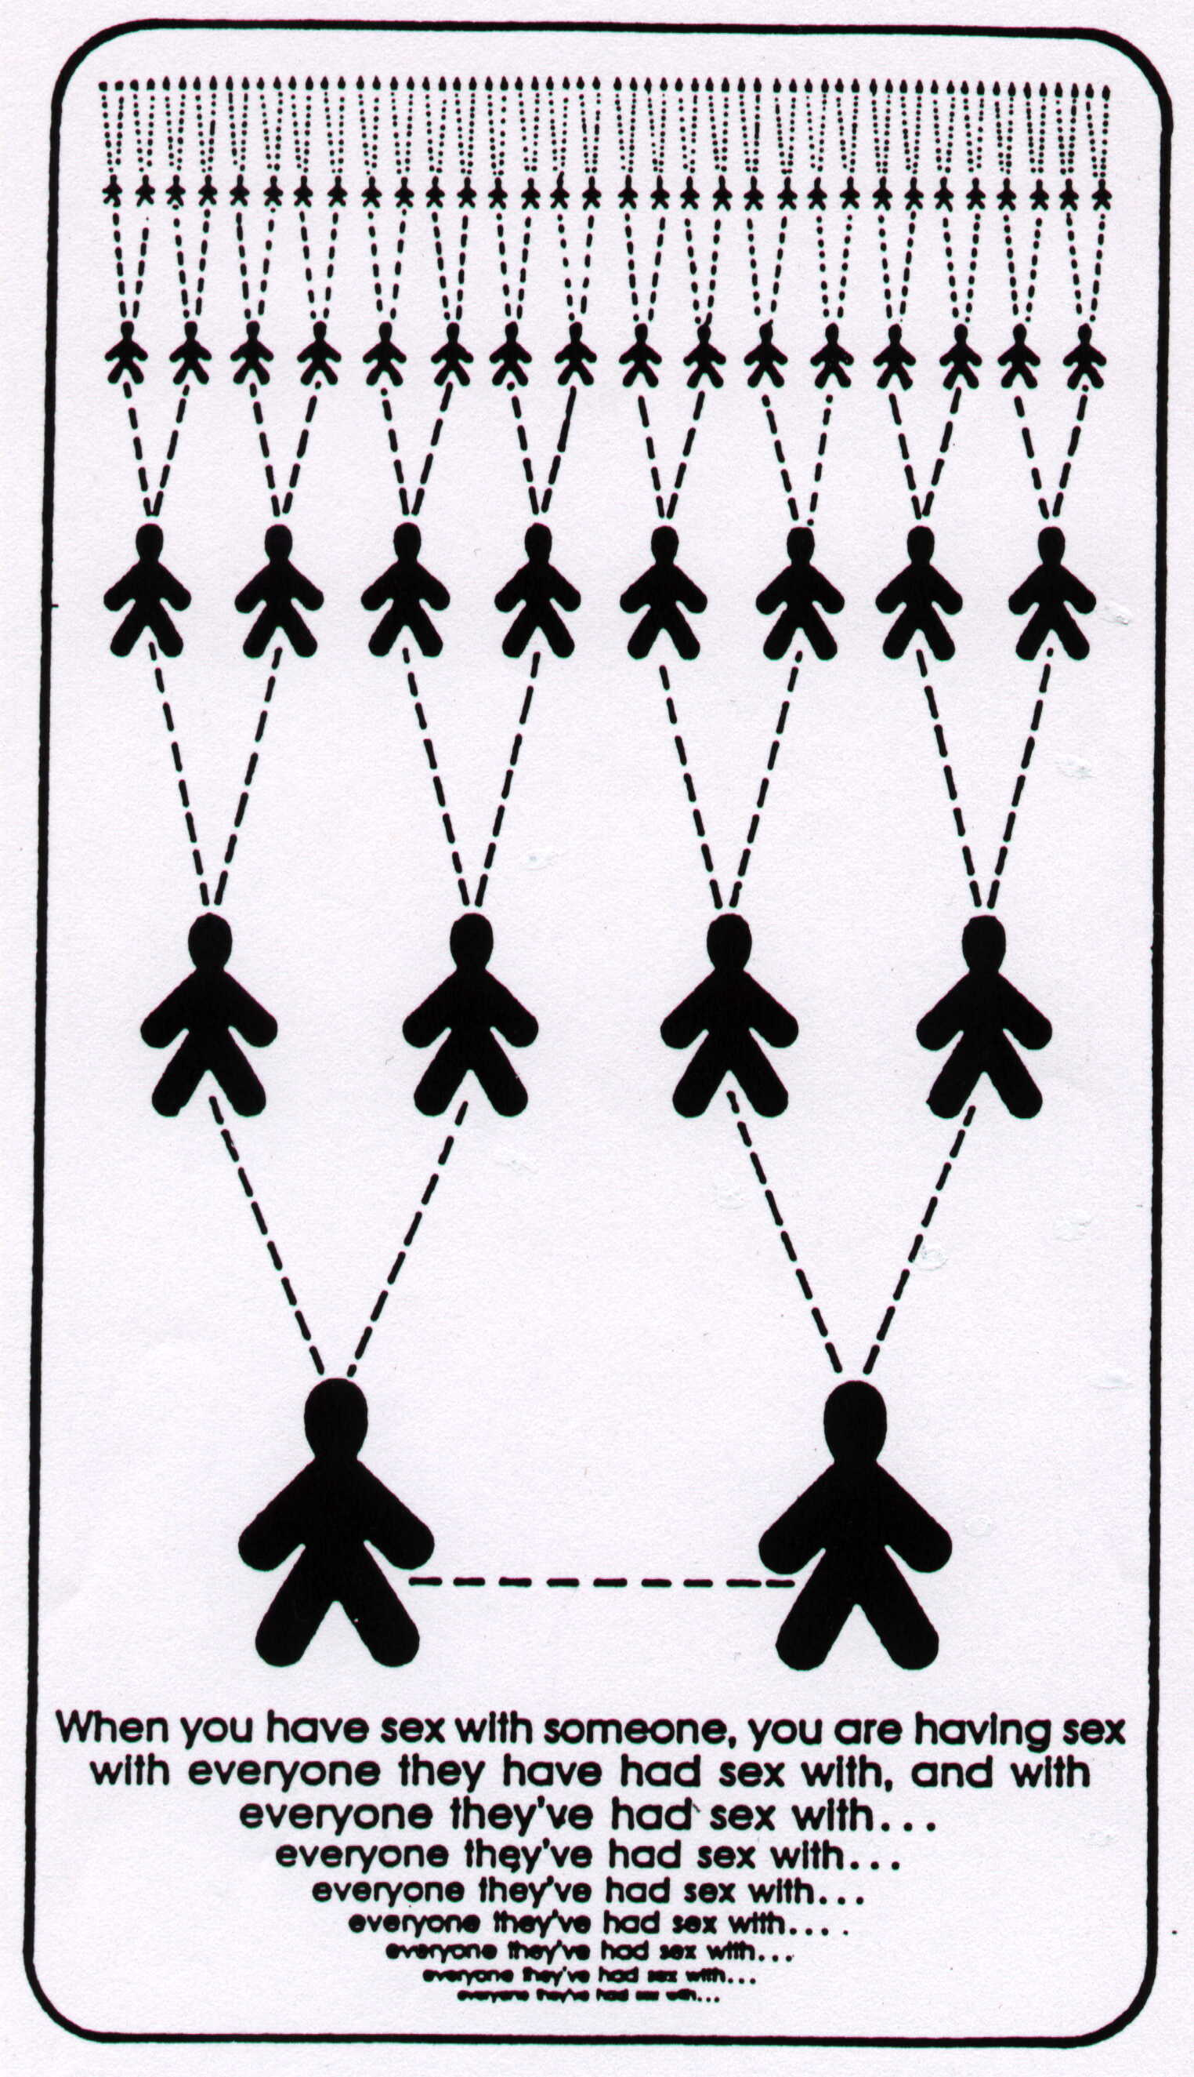

I will exercise self-control and only have sex within marriage. This is Option # 4 and is 100% safe IF the person you marry has also remained a virgin and has not engaged in sexual behaviour that puts him/her at risk for HIV infection. God places such a high value on individuals that He prescribes Option #4 ONLY as the safe context for sexual expression and fulfilment. Unmarried persons then must choose to WAIT until marriage for sex. Married persons must choose to remain faithful sexually to their

SEXU 08

SEXU 69
spouse.

SEXU 71

SEXU 69
What about polygamy (having more than one wife)? Medically, in terms of HIV spread and AIDS, if a man marries more than one virgin woman and has more than one wife, and IF he never moves sexually outside of the circle of his wives for sex, then he is not at risk for HIV infection. However, while the polygamist who is faithful to his wives may not be at risk, the number of sexual partners one has ALWAYS presents a higher risk for HIV and AIDS. Having more than one wife allows for more possibility of AIDS entering a family for the following reasons:

SEXU 12

SEXU 11
- The man may not know the virginity status accurately of each wife. It is more difficult to know the status of more than one woman in a marriage

- It is possible that a woman may have been HIV infected through casual spread (i.e. rape, molestation, birth depending on her age, etc. The man may be taking more than one wife to satisfy his sexual urges, rather than exercising self-control. The possibility for this man to develop a sexual addiction, habits of sexual promiscuity, etc., are far greater than for the husband of one wife

- The family is at greater economic risk because of the cost of adequately caring for and educating the many children, than the single-wife husband. This can cause children to become undisciplined and perhaps move into risky sexual behaviour themselves as they get older.

It is critical that the Christian Church be the voice of moral conscience in a world of AIDS, teaching obedience to God, moral values, right choices about sex, respect of oneself and others, and non-discrimination toward those who are already infected. No institution or organization, other than the Church, is able to rightly speak to these issues. Biblically, God’s very best for mankind is to be married at the right time, with one man or woman, (1 Timothy 3:2) and to keep sex within that marriage until death. Only upon death of a spouse is one free to marry again. This is God’s very best for sexual fulfilment (1 Corinthians 6 and 7). It is incumbent upon us all to be a strong voice that can give direction to a lost generation.

REFR 15

SEXU 06

SEXU 05

